**Test Case 2**

Start new game with “N”|”2”|”John”|”J”|”Derek”|”D”

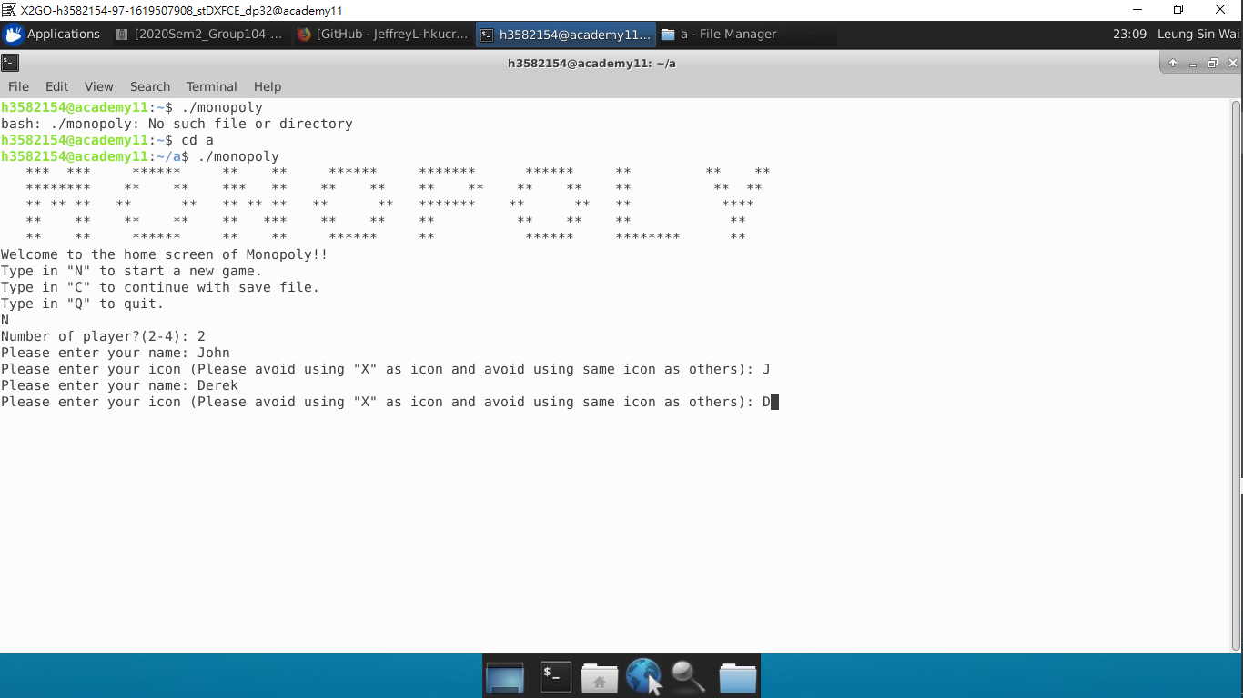

This game board will show up

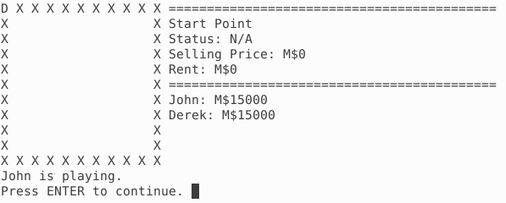

Press ENTER

[Random] rolling dice

Press ENTER twice

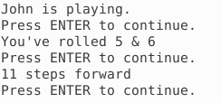

After rolling dice, the game board will be print again

[Random event] If step on a land, it will show the information for this land.

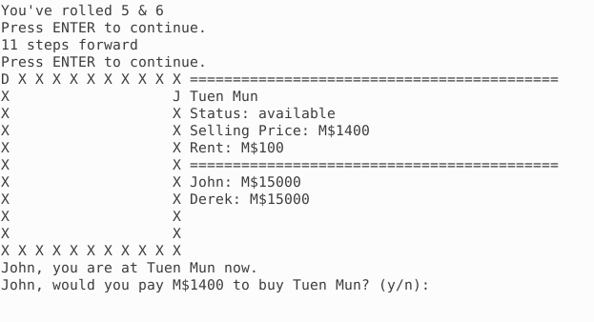

Type in “y”.

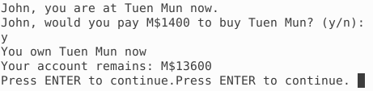

Press ENTER, this will show up, you can see that John’s balance has deducted.

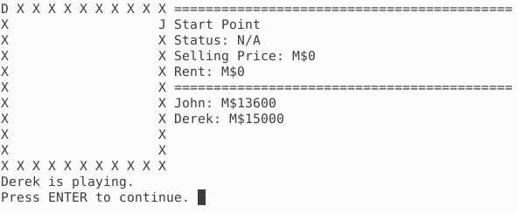

Similar input for Derek.

